QA-Session-3and4-Assignment

- TDD(Test Driven Development) is good for the systems, as it focuses on how functionality is implemented rather than focusing on end user needs. Above given applications suits this purpose.
- In the Software Life Cycle Test Automation fits in between development and manually Testing
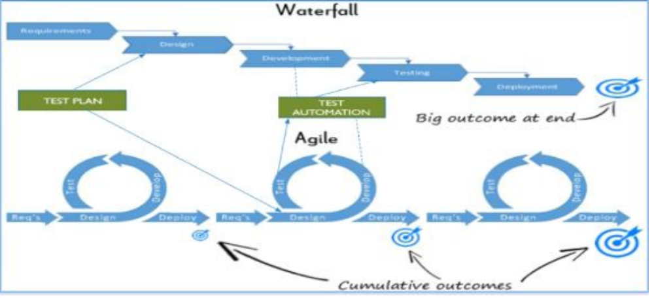

- No, Automation Testing are just robotic and can’t act as a real user prospective., on the other end Manual testing allows the developing program to be used as it would be upon launch. Any bugs that may pop up when a user handles the program in a certain way are more likely to be caught with manual testing.
4.
- Targeting using Ids

<input id="email" value=""> #email
- Targeting using attributes

<input name="email" value=""> [name="email"]
- Targeting using class names
<div class="some-class another-class">...</div>

.some-class.another-class

- Targeting using element tag

<div class="username">Justin</div>

<span class="username">Justin</span> div.username
span.username

- Targeting using hierarchy

<div class=”name”>

<label>John</label>

</div>

.name label

- Targeting using ordering

<ul class=”fruits”>

<li>Apple</li>

<li>Banana</li>

<li>Coconut</li>

</ul>

.fruits li:nth-child(2)

5.
- Driver scripts “drive” test execution
- Interaction with the SUT done by functions in a test library
- The objects are defined once and reusable in all test methods.
- Small and to-the-point methods are created for individual functionalities
- The test case is the collection of these small methods and reusable objects
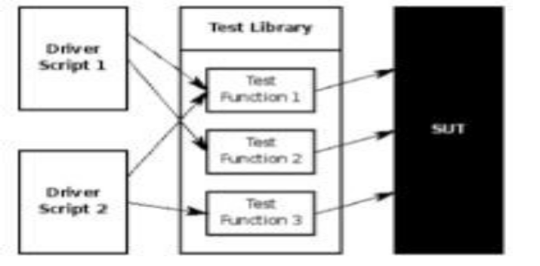

- Open-source tools are software tools that are freely available without a commercial license. Many different kinds of open-source tools allow developers and others to do certain things in programming, maintaining technologies or other types of technology tasks.
7.
- Use the combination of two or more of the above-mentioned techniques, taking from their strengths and minimizing their weaknesses.
- The framework can use the modular approach along with either data-driven or keyword-driven framework.
- The framework can use scripts to perform some tasks that might be too difficult to implement in a pure keyword driven approach.

8. Selenium IDE, record and replay approach is popular approach among commercial tools.Its very easy to use and need no programming skills.
9.

BDD (Behavior Driven Development) technique is a software development technique that defines the user behavior prior to writing test automation scripts or the functional pieces of code.

While, Cucumber is a framework for writing and executing high level descriptions of your software's functionality.

Cucumber plays a central role in a development approach called Behaviour Driven Development (BDD)
- The words “automated” and “regression testing” go hand-in-hand. When companies first consider how they can maximize their QA teams’ potential through automation, they look to regression tests.

This is because regression tests are naturally good candidates for automation. In general, automated test cases should be:

- Stable
- Repeated frequently
- Simple
- Worth maintaining
- 11.
- ARRANGEMENT or Object Identification
- We identify objects (buttons, dropdowns etc.) either by their ids, names or by their Window Titles etc.
- In case of web application, we identify by user ID, or By XPath or By CSS or By Class Name etc. If nothing works, we then identify objects by using mouse coordinates (But it is not a reliable method of object identification).
- ACTION on the Identified Object
- When the objects are identified, we perform some kind of action on it either by mouse or by keyboard. For example, either we click, or we double-click, or we mouse hover over it or sometimes we
drag-drop. Sometimes we write on text boxes. So any kind of action we perform on these objects are covered in this second step.
- ASSERTION
- The assertion is basically checking the object with some expected result. For example, if we press 2+3 on the calculator, the screen should show 5.

